FINAL YEAR PROJECT MANAGEMENT SYSTEM-FYPMS

**Design Document**

**Version 1.0**



**Group Id:** F2202E93DE

**Supervisor Name:** Fizzah

**Revision History**

|  |  |  |  |
| --- | --- | --- | --- |
| **Date (dd/mm/yyyy)** | **Version** | **Description** | **Author** |
| 24 Feb, 2023 | 1.0 | Design Document is collection of documents and resources. Design Document is used to provide a description of the design of a system and to provide an understanding of what is to be built and how it is expected to construct. | MC210401279 |
|  |  | In this document, we have included ERD, Sequence and Class Diagram, Database and Interface Design, and Test Cases. |  |
|  |  |  |  |
|  |  |  |  |

**Table of Contents**

1. Introduction of Design Document ___________________Page no.4
2. Entity Relationship Diagram (ERD)__________________Page no.6
3. Sequence Diagrams______________ _________________Page no.8
4. Architecture Design Diagram _______________________Page no.14
5. Class Diagram _______________________________ Page no.15
6. Database Design_______________ __________________Page no.17
7. Interface Design_____________________ ____________Page no.19
8. Test Cases _____________________________________Page no.27

**1.1: Introduction of Design Document**

Design Document covers all aspects of a project. It is the layout plans and specification of the project. It is a complete high level solution of the given problem. It may be a single or multiple design documents depending upon the requirements. Design document describe the system requirements, system and subsystem architecture, processing logic and external interface. The main purpose of this document is to formally document the design of software.

The objective of the Design document is to present the application graphically. This application provides robust solution for the problems faced by students and supervisors in managing final year projects manually and to enhance efficiency of project management system. Moreover, this application is intended to replace the manual project management system with advanced computerized project management system.

**Benefits of Design Document:**

* A design document helps to create better desktop application in an efficient and compact manner.
* It helps to understand project specifications.
* It accelerates the project by providing a clear reference all rounds.
* It provides documentations for future.

**Activities that are used in this document are as follows:**

* Entity Relationship Diagram (ERD)
* Sequence Diagrams
* Architecture Design Diagram
* Class Diagram
* Database Design
* Interface Design
* Test Cases

**2.1: Entity Relationship Diagram (ERD)**

ER model stands for an Entity-Relationship model. It is a high-level data model. This model is used to define the data elements and relationship between them. It develops conceptual design for the database in an easy way. In an Entity relationship model, entities are represented as a diagram called Entity Relationship Diagram ERD.

ERD of project Management system is given below:

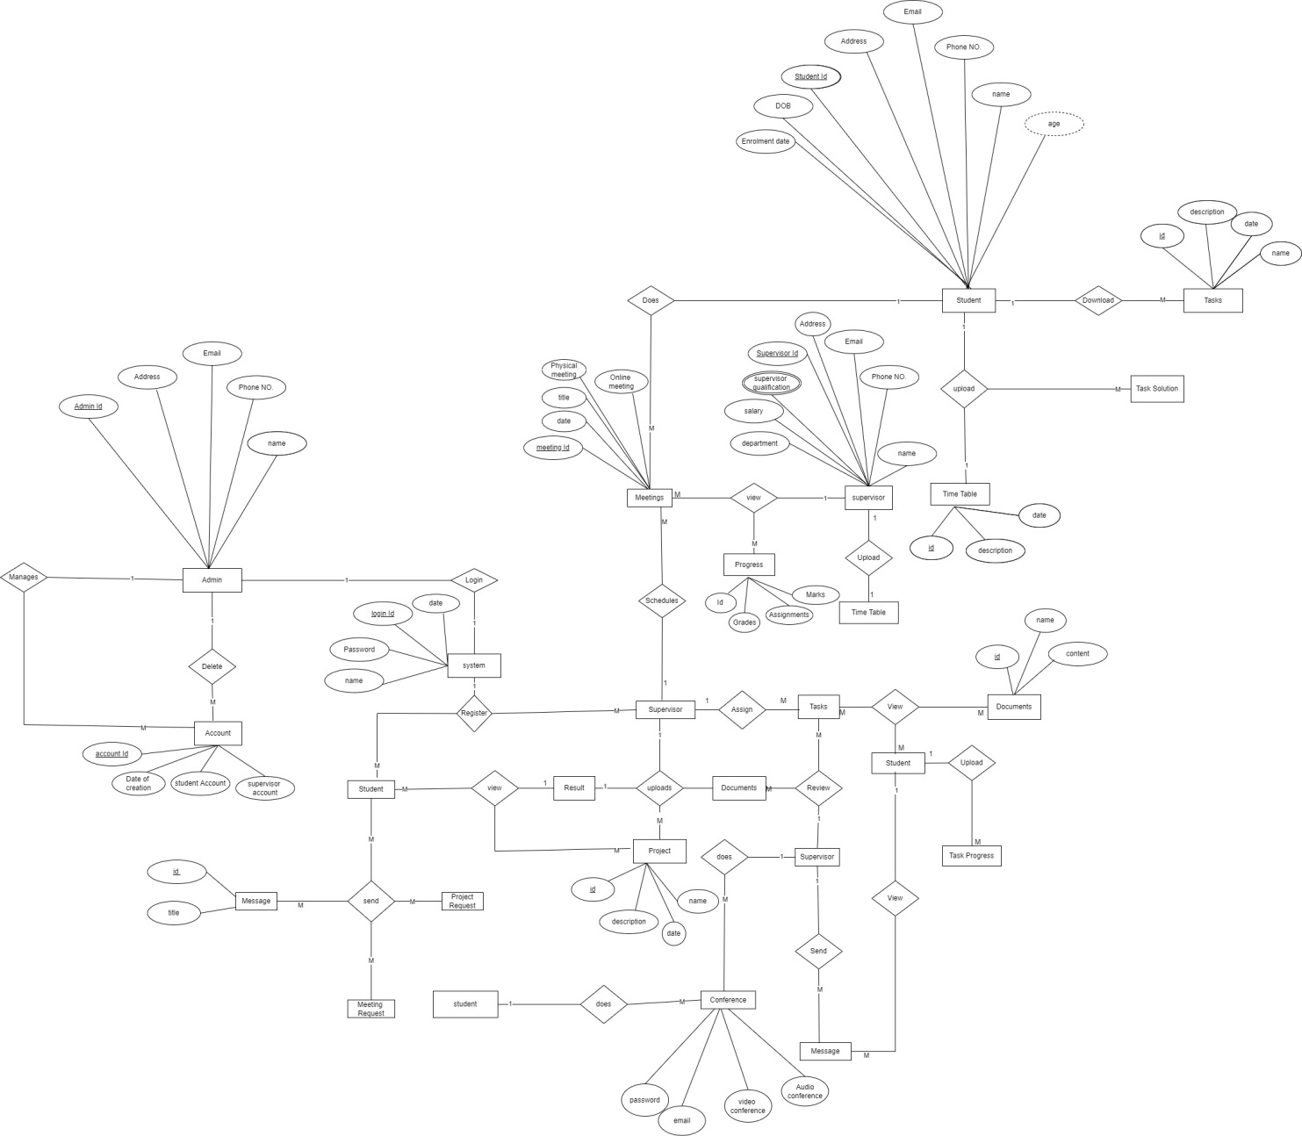

**Figure 2-1 ERD of Final Year Project Management System (FYPMS)**

**3.1: Sequence Diagrams**

Sequence diagrams are UML diagram that shows how objects in a system interact with each other. It also shows control structures and sequence of messages passed between objects.

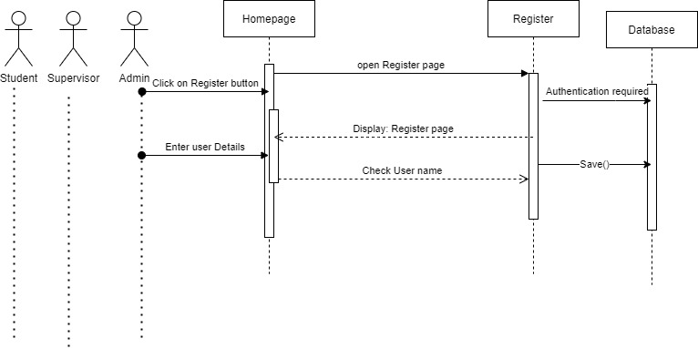**3.2: Registration Sequence Diagram**

**Figure 3-2 Registration sequence diagram**

**3.3: Login Sequence Diagram**

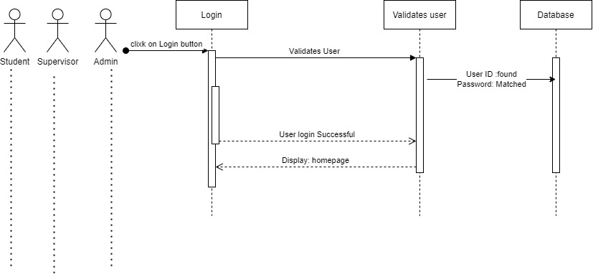

**Figure 3-3 Login sequence diagram**

**3.4: Manage Accounts Sequence Diagram**

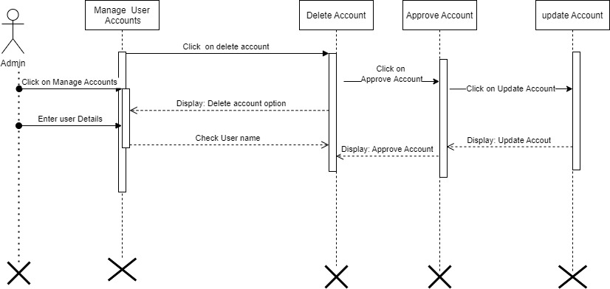

**Figure 3-4 Manage Accounts sequence diagram**

**3.5: Student’s Sequence Diagram**

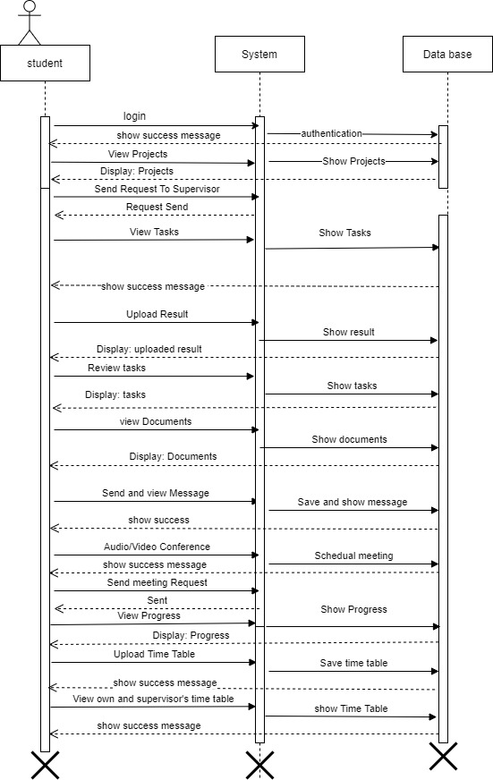

**Figure 3-5 Student sequence diagram**

**3.6: Supervisor’s Sequence Diagram**

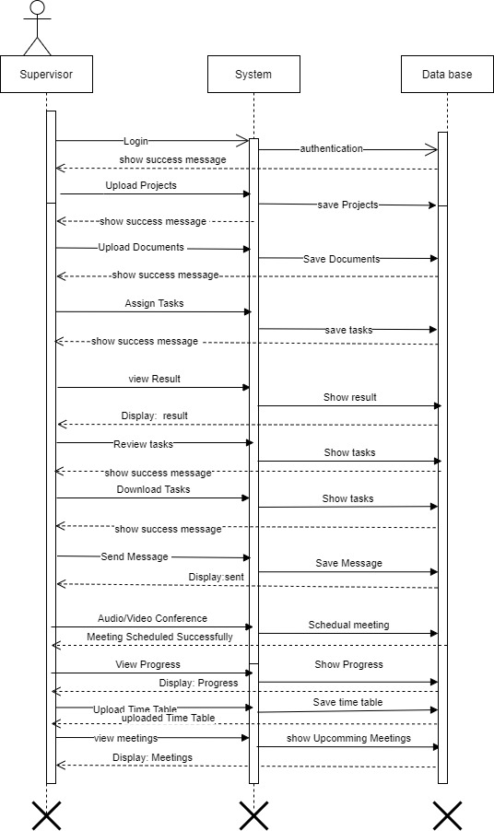

**Figure 3-6 Supervisor sequence diagram**

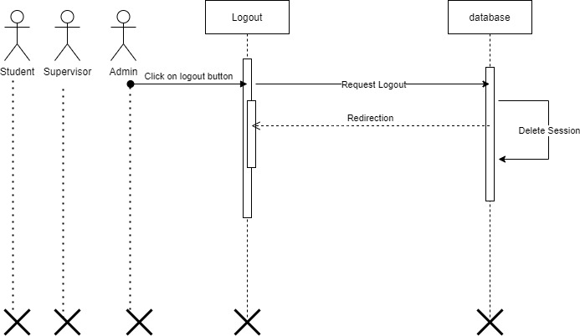**3.7: Logout Sequence Diagram**

**Figure 3-7 Logout sequence diagram**

**4.1: Architecture Design Diagram**

The main reason to develop FYPMS is to provide a user-friendly web environment which can perfectly manage projects.

**The system shall have four components:**

1. Client side

2. Server side

3. Database back-end and web-based administration tool

4. Graphical front-end

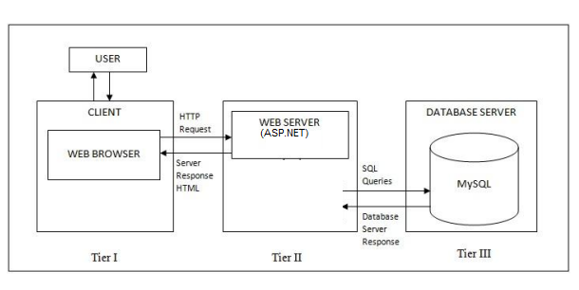

**Figure 4-1 Architecture Design**

**FYPMS architecture consists of three tiers:**

The user interface in the client browser,

The Web server,

The database server

**5.1: Class Diagram**

The class diagram is the main building block of object-oriented modeling. It is used for general conceptual modeling of the structure of the application, and for detailed modeling, translating the models into programming code.

Class diagram of FYPMS is:

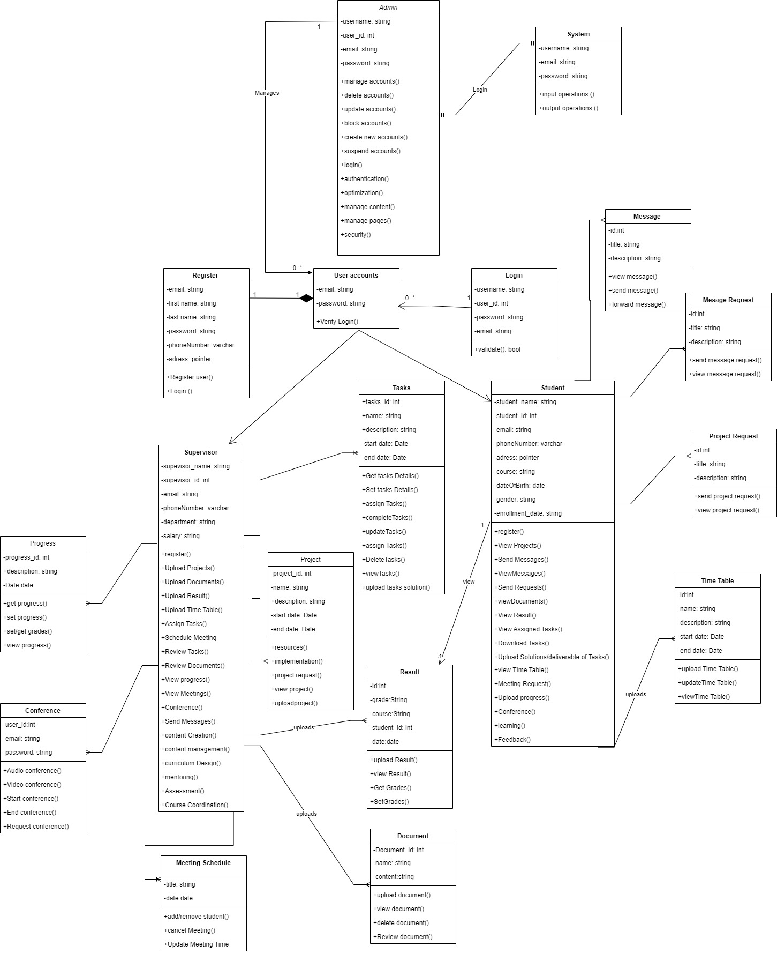

**Figure 5-1 Class diagram of FYPMS**

**6.1: Database Design**

Database diagrams graphically show the structure of the database and relations between database objects. Using database diagram, we can create, update and modify tables, columns and keys. This data base design represents basic structure of our project. It graphically shows how information is stored, managed and categorized in it.

Data base design of FYPMS is:

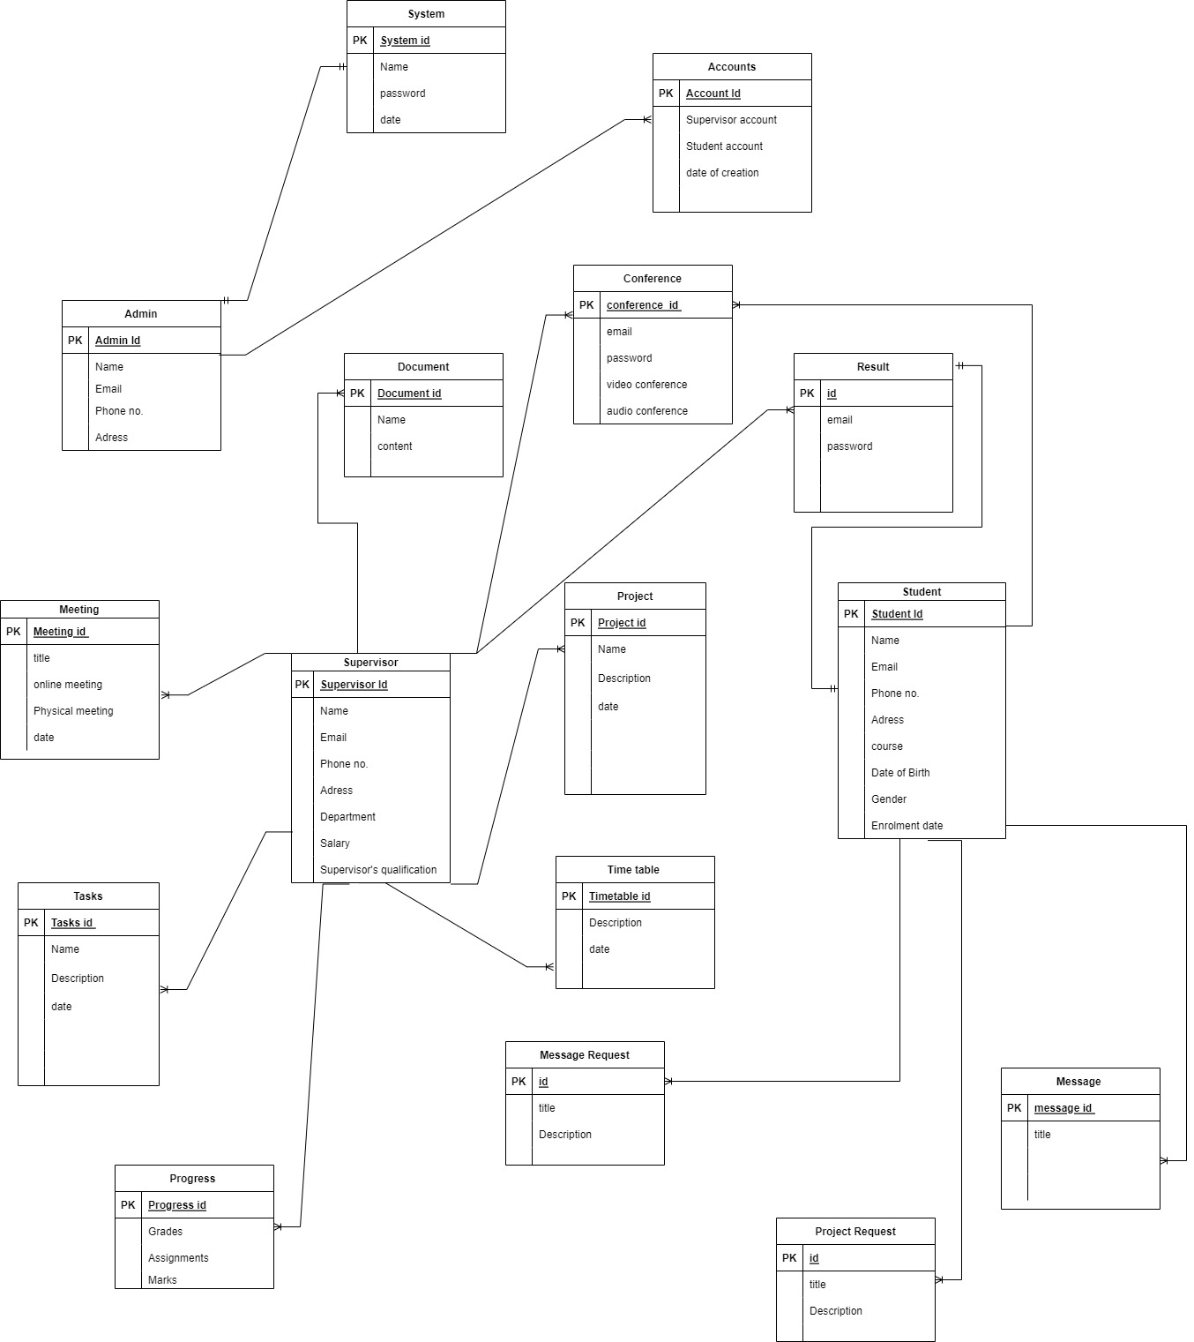

**Figure 6-1: Database Design of FYPMS**

**7.1: Interface Design**

Interface design is used to build interfaces in software or computerized devices. It focuses on looks and styles of the software.

First, when a user types the URL of FYPMS, the homepage of FYPMs will be opened. In this page, there are login column, latest announcement, and some other details which will be updated.

**7.2: Registration form of FYPMS**:

First, when a user types the URL of FYPMS, the registration page of FYPMs will be opened. In this page user will get registered.

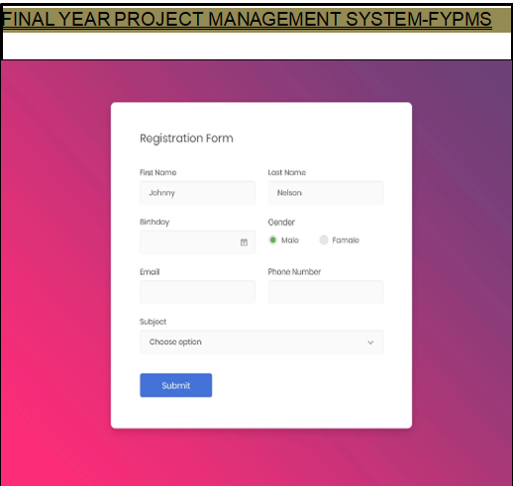

**Figure 7-2: Registration form of FYPMS**

**7.3: Login Form:**

It is authenticated by username and password. Admin will determine access level of the user.

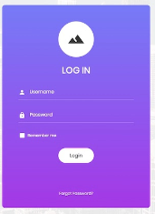

**Figure 7-3: Login Form of FYPMS**

**7.4: User’s Dashboard:**

After Login, The user will be redirected to its dashboard i.e., Student’s dashboard, Supervisor’s or admin’s Dashboard. It is a main navigation page.

**GUI of Student’s dashboard is:**

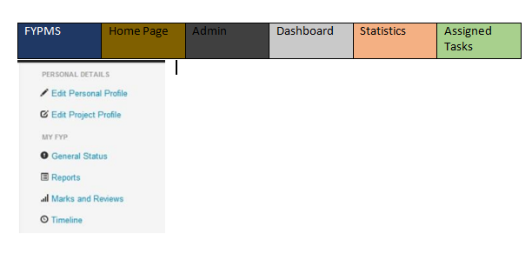

**Figure 7-4.1: GUI of student on FYPMS**

**GUI of Supervisor’s dashboard is:**

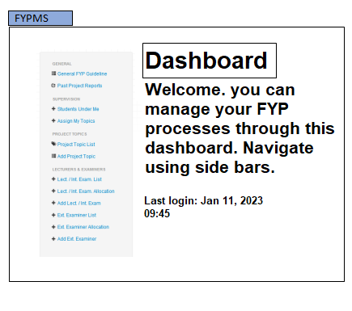

**Figure 7-4.2: GUI of Supervisor on FYPMS**

**7.5: GUI of Project Page:**

After authentication and confirmation student would be able to see projects assigned by the Supervisor and also Supervisor name.

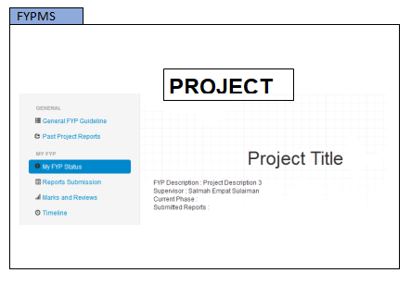`

**Figure 7-5: GUI of Supervisor on FYPMS**

**7.6: Assignment/ Task page:**

In this page supervisor can assign projects and tasks to the students. Student can download documents or tasks file and can submit tasks solutions.

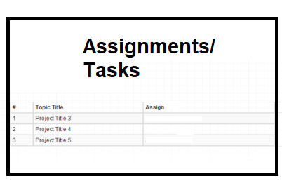

**Figure 7-6: Assignment/task page of FYPMS**

**7.7: Result Page:**

In this page supervisor can upload results, marks and also comment on the uploaded files and solutions. Supervisor can view progress. Student can see the results and marks of the student.

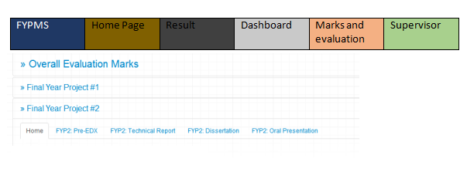

**Figure 7-7: Result Page of FYPMS**

**8.1: Test Cases**

A test case is set of actions executed to verify a particular feature or functionality of software applications.

**Test Case # 1**

**Test Case Title:** Registration

|  |  |
| --- | --- |
| Pre- condition | The user must have internet connection. |
| Actions | The user must enter First name, Last name, valid email and valid password confirm password. And then click on Submit. |
| Expected Results | User Registered successfully. |
| Tested by | MC210401279 |
| Result | Pass |

**Test Case # 2**

**Test Case Title:** Login

|  |  |
| --- | --- |
| Preconditions | User should have registered on the system. |
| Actions | Click the Login button on the Login page |
| Expected Results | System should login the user into the system. |
| Tested By: | MC210401279 |
| Result | Pass |
|  |  |

**Test Case # 3**

**Test Case Title:** Manage accounts

|  |  |
| --- | --- |
| Preconditions | * Admin will manage students and supervisor accounts. Admin can delete, update and approve students and supervisor accounts. * Admin should have logged in to the system. |
| Actions | Click the Manage accounts. Select update, delete, approve or create account. Click on Ok button. |
| Expected Results | System should process the requested command. |
| Tested By: | MC210401279 |
| Result | Pass |
|  |  |

**Test Case # 4**

**Test Case Title:** Schedule Meetings (Physical or Online)

|  |  |
| --- | --- |
| Preconditions | * Supervisor will schedule meetings in application. Meetings can be physical or online depending upon supervisor requirements * Supervisor should have logged in to the system. |
| Actions | Click the Schedule meetings. Schedule a meeting (physical or online). Click on Notify students. Click on Ok button. |
| Expected Results | System should schedule meetings as per supervisor requirements. |
| Tested By: | MC210401279 |
| Result | Pass |
|  |  |

**Test Case # 5**

**Test Case Title:** Upload Documents

|  |  |
| --- | --- |
| Preconditions | * Supervisor will upload Documents in application. * Supervisor should have logged in to the system. |
| Actions | Click the upload documents. Upload required document. Select document format. Click on Ok button. |
| Expected Results | System should upload documents. |
| Tested By: | MC210401279 |
| Result | Pass |
|  |  |

**Test Case # 6**

**Test Case Title:** Upload Projects

|  |  |
| --- | --- |
| Preconditions | * Supervisor will upload projects in application. * Supervisor should have logged in to the system. |
| Actions | Click the upload projects. Upload required projects. Click on Ok button. |
| Expected Results | System should upload projects. |
| Tested By: | MC210401279 |
| Result | Pass |
|  |  |

**Test Case # 7**

**Test Case Title:** Audio/ Video conferencing

|  |  |
| --- | --- |
| Preconditions | * Supervisor and Students will conference that could be audio or video. * Supervisor and student should have logged in to the system |
| Actions | Click the create conference. Click on Ok button. |
| Expected Results | System should create conference on conference page. |
| Tested By: | MC210401279 |
| Result | Pass |
|  |  |

**Test Case # 8**

**Test Case Title:** Send Message

|  |  |
| --- | --- |
| Preconditions | * Supervisor and Students will send message. * Supervisor and student should have logged in to the system |
| Actions | Click the Message icon. Write message. Click on send. |
| Expected Results | System should send message. |
| Tested By: | MC210401279 |
| Result | Pass |
|  |  |

**Test Case # 9**

**Test Case Title:** Upload Time Table

|  |  |
| --- | --- |
| Preconditions | * Supervisor and Students will upload time table. * Supervisor and student should have logged in to the system |
| Actions | Click the time table. Upload time table. Click on upload. |
| Expected Results | System should upload time table. |
| Tested By: | MC210401279 |
| Result | Pass |
|  |  |

**Test Case # 10**

**Test Case Title:** Assign tasks

|  |  |
| --- | --- |
| Preconditions | * Supervisor will assign tasks to the student. * Supervisor should have logged in to the system |
| Actions | Click the assign tasks. Assign tasks. Click on OK. |
| Expected Results | System should assign tasks. |
| Tested By: | MC210401279 |
| Result | Pass |
|  |  |

**Test Case # 11**

**Test Case Title:** View Progress

|  |  |
| --- | --- |
| Preconditions | * Supervisor will view progress of the student. * Supervisor should have logged in to the system |
| Actions | Click the view progress. |
| Expected Results | System should show progress. |
| Tested By: | MC210401279 |
| Result | Pass |
|  |  |

**Test Case # 12**

**Test Case Title:** View Meetings

|  |  |
| --- | --- |
| Preconditions | * Supervisor will view meetings. * Supervisor should have logged in to the system |
| Actions | Click On the meetings. |
| Expected Results | System should show upcoming meetings. |
| Tested By: | MC210401279 |
| Result | Pass |
|  |  |

**Test Case # 13**

**Test Case Title:** Review documents

|  |  |
| --- | --- |
| Preconditions | * Supervisor will review meetings. * Supervisor should have logged in to the system |
| Actions | Click On review meetings. |
| Expected Results | System should show meetings. |
| Tested By: | MC210401279 |
| Result | Pass |
|  |  |

**Test Case # 14**

**Test Case Title:** Review tasks

|  |  |
| --- | --- |
| Preconditions | * Supervisor will review tasks. * Supervisor should have logged in to the system |
| Actions | Click On tasks button. |
| Expected Results | System should show tasks. |
| Tested By: | MC210401279 |
| Result | Pass |
|  |  |

**Test Case # 15**

**Test Case Title:** Upload Result

|  |  |
| --- | --- |
| Preconditions | * Supervisor will upload result. * Supervisor should have logged in to the system |
| Actions | Click On result and upload results. Click on  Ok. |
| Expected Results | System should show results. |
| Tested By: | MC210401279 |
| Result | Pass |
|  |  |

**Test Case # 16**

**Test Case Title:** View Projects

|  |  |
| --- | --- |
| Preconditions | * Supervisor will view projects. * Supervisor should have logged in to the system |
| Actions | Click On projects. |
| Expected Results | System should show projects. |
| Tested By: | MC210401279 |
| Result | Pass |
|  |  |

**Test Case # 17**

**Test Case Title:** View Projects

|  |  |
| --- | --- |
| Preconditions | * Supervisor will view projects. * Supervisor should have logged in to the system |
| Actions | Click On projects. |
| Expected Results | System should show projects. |
| Tested By: | MC210401279 |
| Result | Pass |
|  |  |

**Test Case # 18**

**Test Case Title:** Request to supervisor

|  |  |
| --- | --- |
| Preconditions | * Student will send request to supervisor. * Student should have logged in to the system |
| Actions | Click On send request. |
| Expected Results | System should send request to supervisor. |

|  |  |
| --- | --- |
| Tested By: | MC210401279 |
| Result | Pass |

**Test Case # 19**

**Test Case Title:** View Assigned tasks

|  |  |
| --- | --- |
| Preconditions | * Student will view assigned tasks. * Student should have logged in to the system |
| Actions | Click assigned tasks. |
| Expected Results | System should show tasks to student on system. |

|  |  |
| --- | --- |
| Tested By: | MC210401279 |
| Result | Pass |

**Test Case # 20**

**Test Case Title:** Download tasks

|  |  |
| --- | --- |
| Preconditions | * Student will download tasks. * Student should have logged in to the system |
| Actions | Click on tasks. Click on download button. |
| Expected Results | System should download the tasks. |

|  |  |
| --- | --- |
| Tested By: | MC210401279 |
| Result | Pass |

**Test Case # 21**

**Test Case Title:** Upload Solution

|  |  |
| --- | --- |
| Preconditions | * Student will upload solution. * Student should have logged in to the system |
| Actions | Click solution. Upload the solution on system from the browser. Click on Upload |
| Expected Results | System should upload tasks solution. |
| Tested By: | MC210401279 |
| Result | Pass |
|  |  |

**Test Case # 22**

**Test Case Title:** View Message

|  |  |
| --- | --- |
| Preconditions | * Student will view message. * Student should have logged in to the system |
| Actions | Click message icon. |
| Expected Results | System should show messages. |
| Tested By: | MC210401279 |
| Result | Pass |
|  |  |

**Test Case # 23**

**Test Case Title:** View Result

|  |  |
| --- | --- |
| Preconditions | * Student will view result. * Student should have logged in to the system |
| Actions | Click on result. |
| Expected Results | System should show result to the student. |
| Tested By: | MC210401279 |
| Result | Pass |
|  |  |

**Test Case # 24**

**Test Case Title:** View Time Table

|  |  |
| --- | --- |
| Preconditions | * Student will view time table. * Student should have logged in to the system |
| Actions | Click on time table. |
| Expected Results | System should show time table to the student. |
| Tested By: | MC210401279 |
| Result | Pass |

**Test Case # 25**

**Test Case Title:** View Documents

|  |  |
| --- | --- |
| Preconditions | * Student will view documents. * Student should have logged in to the system |
| Actions | Click on documents. |
| Expected Results | System should show documents to the student. |
| Tested By: | MC210401279 |
| Result | Pass |
|  |  |

**Test Case # 26**

**Test Case Title:** Meeting Request

|  |  |
| --- | --- |
| Preconditions | * Student will send meeting request to the supervisor. * Student should have logged in to the system |
| Actions | Click on Meetings. Send request to the supervisor. |
| Expected Results | System should send message request. |
| Tested By: | MC210401279 |
| Result | Pass |
|  |  |

**Test Case # 27**

**Test Case Title:** Task Progress

|  |  |
| --- | --- |
| Preconditions | * Student will view tasks progress. * Student should have logged in to the system |
| Actions | Click on tasks. Click on progress. |
| Expected Results | System should show progress to the student. |
| Tested By: | MC210401279 |
| Result | Pass |

**Test Case # 28**

**Test Case Title:** Logout

|  |  |
| --- | --- |
| Preconditions | User should have registered on the system. |
| Actions | Click the Logout button on the system |
| Expected Results | System should logout the user from the system. |
| Tested By: | MC210401279 |
| Result | Pass |
|  |  |